**A&L Engineering**

**Case Material Evaluation Report**

Analyst: Matthew Pool

8/6/2022

# Newton’s Three Laws of Motion

## Isaac Newton’s laws of motion are used in the realm of classical mechanics, the study of stuff that isn’t microscopic or moving near the speed of light ($which is 299,792,458\frac{m}{s}$). These scientific laws of nature describe the relationship between the motion of an object and the forces acting upon it.

## 1st Law of Motion: $inertia$

## An object in motion or an object at rest stays in motion or at rest, respectively, until acted upon by an external force. The gravitational force from Earth’s mass accelerates the phone (and case, if applicable) towards the Earth, and doesn’t stop until it makes contact.

**2nd Law of Motion: $force=mass*acceleration$**

The force of an object is directly proportional to its acceleration. The greater the acceleration, or change in velocity (speed) over time, the greater the force that object will emit when opposed. This will be seen when the phone (or case) is dropped and accelerates until the moment it contacts the ground, at the peak of its velocity.

**3rd Law of Motion: $F=-F$**

For every force, or action, there is an equal reaction of the same magnitude (strength) in the opposing direction. As the phone is pulled to the ground by the acceleration of Earth’s gravity, friction (in the form of air resistance) will oppose that force; although, this will be negligible. But when the phone hits the ground, the normal (reaction) force from the Earth will oppose the force it was met with, using the same amount of force in the opposite direction.

# Force Diagrams

We will be evaluating the magnitude of the force felt by the phone, dropped one meter above the ground, using a variety of different cases.

To help aid in the understanding of the shock-absorption tests and calculations, the corresponding (free-body) force diagrams are shown below (on the next two pages).

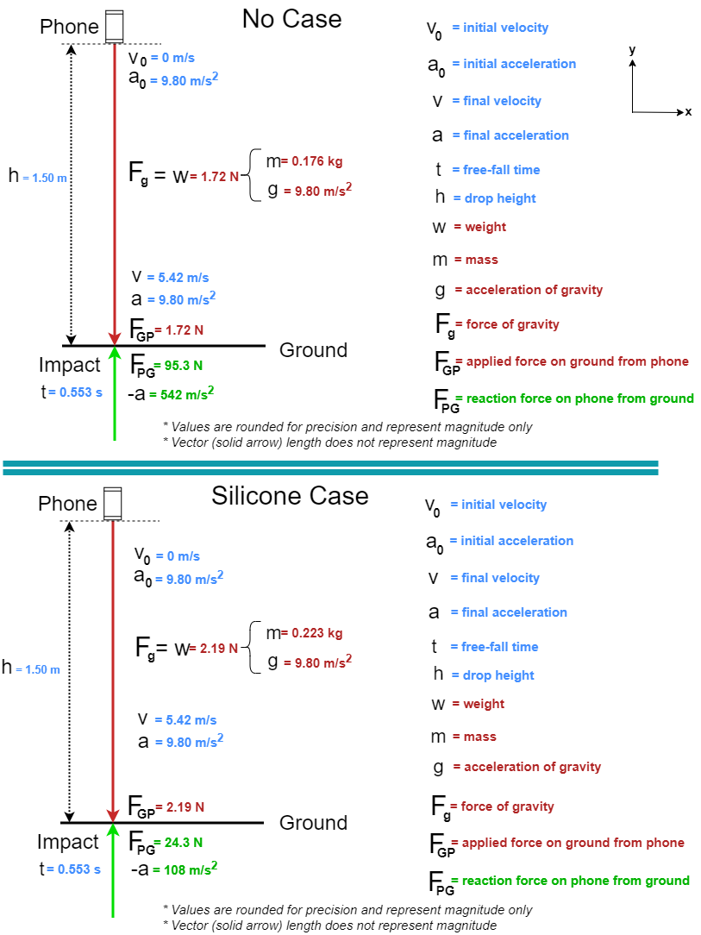

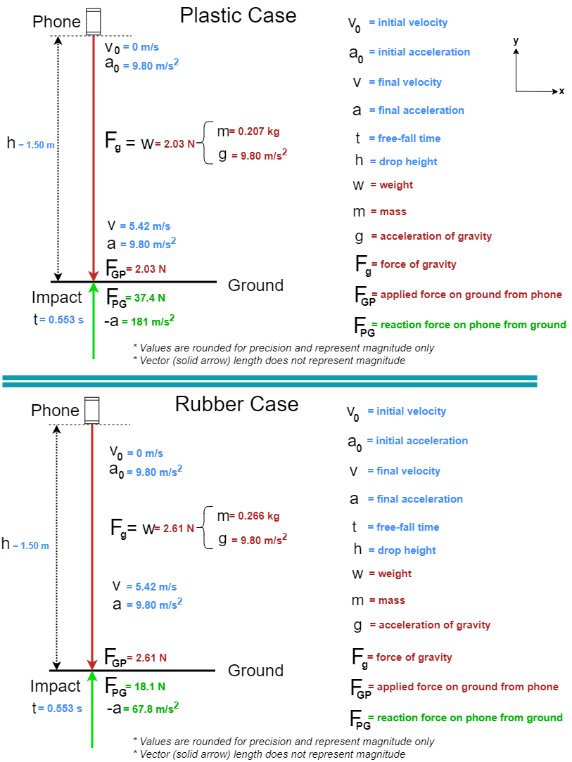

**Calculations**

***LEGEND***

$$∆ =Delta \left(difference in final and initial values\right)$$

$$∴ =therefore$$

$$≡ =equivelant to \\ TE=Total Energy (at any given point in time) \\ PE=Potential Energy (based on height and gravity) \\ KE=Kinetic Energy (energy of motion) \\ W=work(energy transferred) \\ F_{GP}=force on ground from phone \\ F_{PG}=force on phone from ground \\ F_{net}=net force \\ m=mass \\ u=initial velocity \\ v=final velocity \\ a=acceleration \\ h=free fall distance \\ d=impact depth \\ t_{F}=time of fall \\ t_{C}=time of collision$$

**Ounces to Kilograms** **Formula:**

$$m\left[kg\right]= m\left[oz\right]*\frac{28.3495 g}{1 oz}*\frac{1 kg}{1000 g}$$

**Velocity (right before impact) Formula:**

$$v^{2}=u^{2}+2ah ≡v=\sqrt{2gh}$$

$$Law of Conservation of Energy$$

*Energy cannot be created, nor destroyed – only transformed into another type of energy or transferred into or out of the system.*

$$TE=∆PE+∆KE$$

$$∆PE=mgh$$

$$∆KE=\frac{1}{2}mv^{2}$$

$$∆PE= -∆KE$$

$$∴ mgh=-\frac{1}{2}mv^{2}≡v=\sqrt{2gh}$$

**Velocity (all four scenarios):**

$$v=\sqrt{2gh}=\sqrt{2\left(-9.80\frac{m}{s^{2}}\right)\left(-1.5 m\right)}= ±5.42217668≅-5.42\frac{m}{s}$$

**Free-Fall Time Formula:**

$$v=u+at$$

$thus$**, $t=\frac{∆v}{a}$**

**Free-Fall Time (all four scenarios):**

$$t_{F}=\frac{∆v}{a}=\frac{5.42217668\frac{m}{s}-0}{9.80\frac{m}{s^{2}}}=0.553283335≅0.553 s$$

**Impact Deceleration Formula**

$$v=u+at$$

$$∴a=\frac{∆v}{t}≡-a=-\frac{∆v}{t}$$

**Collision Depth Formula**

$$d=u+\frac{1}{2}at^{2}$$

$$∴d=\frac{1}{2}at^{2}$$

**Force (on phone from ground) Formula**

$$Work-Energy Theorem$$

*The net work done by the forces on an object equals the change in its kinetic energy.*

$$W=Fd\left(cosθ\right)=Fd\left(cos180°\right)=Fd\left(-1\right)=-Fd$$

$$∆KE= -∆PE=-mgh$$

$$W=-∆KE=-\left(-mgh\right)=mgh$$

$$-Fd=mgh$$

$$∴F=-\frac{mgh}{d}$$

**Material Test Runs**

1. **No Case (Phone Only)**

**Conversion**

$$m\left[kg\right]= 6.20 oz*\frac{28.3495 g}{1 oz}*\frac{1 kg}{1000 g}=0.17576690≅0.176 kg$$

**Deceleration**

$$a=\frac{∆v}{t_{C}}=\frac{v-u}{t}=\frac{0-5.42217668\frac{m}{s}}{0.0100 s}=-542.217668≅-542\frac{m}{s^{2}}$$

**Collision Depth**

$$d=\frac{1}{2}at^{2}=\frac{1}{2}{\left(-542.217668\frac{m}{s^{2}})(0.0100 s\right)}^{2}=-0.0271108834≅-0.0271 m$$

**Force (on ground from phone)**

$$F_{GP}=weight=ma=mg=0.17576690 kg\left(-9.80\frac{m}{s^{2}}\right)=-1.722516≅-1.72 N$$

**Force (on phone from ground)**

$$F_{PG}=-\left(\frac{mgh}{d}\right)=-\frac{\left(0.17576690 kg\right)\left(-9.80\frac{m}{s^{2}}\right)\left(-1.50 m\right)}{-0.027111 m}=95.303919≅95.3 N$$

$$F_{net}=F_{GP}+F_{PG}=-1.722516 N+95.303919 N=93.581403≅93.6 N$$

1. **Silicone Case**

**Conversion**

$$m\left[kg\right]=m\left[phone\right]+1.70 oz*\frac{28.3495 g}{1 oz}*\frac{1 kg}{1000 g}=0.22396105≅0.223 kg$$

**Deceleration**

$$a=\frac{∆v}{t_{C}}=\frac{v-u}{t}=\frac{0-5.42217668\frac{m}{s}}{0.0500 s}=-108.443534≅-108\frac{m}{s^{2}}$$

**Collision Depth**

$$d=\frac{1}{2}at^{2}=\frac{1}{2}{\left(-108.443534\frac{m}{s^{2}})(0.0500 s\right)}^{2}=-0.135554 ≅-0.136 m$$

**Force (on ground from phone)**

$$F_{GP}=weight=ma=mg=0.22396105 kg\left(-9.80\frac{m}{s^{2}}\right)=-2.194818≅-2.19 N$$

**Force (on phone from ground)**

$$F_{PG}=-\left(\frac{mgh}{d}\right)=-\frac{\left(0.22396105 kg\right)\left(-9.80\frac{m}{s^{2}}\right)\left(-1.50 m\right)}{-0.135554 m}=24.287128≅24.3 N$$

$$F_{net}=F_{GP}+F_{PG}=-2.194818 N+24.287128 N=22.092309≅22.1 N$$

1. **Plastic Case**

**Conversion**

$$m\left[kg\right]=m\left[phone\right]+1.10 oz*\frac{28.3495 g}{1 oz}*\frac{1 kg}{1000 g}=0.20695135≅0.207 kg$$

**Deceleration**

$$a=\frac{∆v}{t_{C}}=\frac{v-u}{t}=\frac{0-5.42217668\frac{m}{s}}{0.0300 s}=-180.739223≅-181\frac{m}{s^{2}}$$

**Collision Depth**

$$d=\frac{1}{2}at^{2}=\frac{1}{2}\left(-180.739223\frac{m}{s^{2}}\right){\left(0.0300 s\right)}^{2}=-0.081333 m≅-0.0813 m$$

**Force (on ground from phone)**

$$F_{GP}=weight=ma=mg=0.20695135 kg\left(-9.80\frac{m}{s^{2}}\right)=-2.028123≅-2.03 N$$

**Force (on phone from ground)**

$$F_{PG}=-\left(\frac{mgh}{d}\right)=-\frac{\left(-0.20695135 kg\right)\left(-9.80\frac{m}{s^{2}}\right)\left(-1.50 m\right)}{-0.081333 m}=37.404226≅37.4 N$$

$$F_{net}=F_{GP}+F_{PG}=-2.028123 N+37.404226 N=35.376103≅35.4 N$$

1. **Rubber Case**

**Conversion**

$$m\left[kg\right]=m\left[phone\right]+3.20 oz*\frac{28.3495 g}{1 oz}*\frac{1 kg}{1000 g}=0.2664853≅0.266 kg$$

**Deceleration**

$$a=\frac{∆v}{t_{C}}=\frac{v-u}{t}=\frac{0-5.42217668\frac{m}{s}}{0.0800 s}=-67.777209≅-67.8\frac{m}{s^{2}}$$

**Collision Depth**

$$d=\frac{1}{2}at^{2}=\frac{1}{2}\left(-67.777209\frac{m}{s^{2}}\right){\left(0.0800 s\right)}^{2}=-0.216887 m≅-0.217 m$$

**Force (on ground from phone)**

$$F_{GP}=weight=ma=mg=0.2664853 kg\left(-9.80\frac{m}{s^{2}}\right)=-2.611556≅-2.61 N$$

**Force (on phone from ground)**

$$F_{PG}=-\left(\frac{mgh}{d}\right)=-\frac{\left(-0.2664853 kg\right)\left(-9.80\frac{m}{s^{2}}\right)\left(-1.50 m\right)}{-0.216887 m}=18.061630≅18.1 N$$

$$F_{net}=F_{GP}+F_{PG}=-2.611556 N+18.061630 N=15.450074≅15.5 N$$

**Equations of Force: Effects**

**Velocity**

*The velocity of a free-fall drop starts at zero; however, immediately before hitting the ground, the object is traveling at maximum velocity (relative to its drop). Because of the Earth’s gravitational pull, the velocity of an object in free-fall is dependent on its height (or vertical displacement):*

$$velocity=sqrt(2gh)$$

*Because the drop-height for all four scenarios is the same, there is no difference in velocity between these samples, with a maximum velocity of approximately $5.42\frac{m}{s}$.*

**Acceleration**

*The acceleration of the falling object remains constant, since we are assuming free-fall motion, and is equal to its own weight, until hitting the ground and decelerating quickly to zero. Note that the letter ‘g’ stands for the acceleration due to Earth’s gravity:*

$$force=mass*acceleration→acceleration=\frac{force}{mass}$$

$$a=\frac{F}{m}=\frac{w}{m}=\frac{mg}{m}=g=9.80\frac{m}{s^{2}}$$

*Upon making impact with the ground, the much larger mass of the ground causes the object to decelerate (slow down) in a fraction of a second. Using the velocity right before impact as the starting velocity and assuming zero to be its final velocity, we calculate this deceleration with the following equation:*

$$a=\frac{∆v}{t_{C}}=\frac{v-u}{t}$$

**Force**

*In free-fall (when considering negligible air resistance) the only thing to decelerate a falling object is the ground. The (perpendicular) “normal” force exerted back from the ground to the phone will be equal in magnitude to the force from the phone but will oppose it directly, as seen in Newton’s third law of motion:*

$${force}_{Normal}=-{force}_{Phone}$$

*Although, the ground may have a negligible amount of elasticity, the Earth will have no problem stopping the phone dead in its tracks, and according to Newton’s second law, this is due to Earth’s much greater mass:*

$$force=mass*acceleration$$

**Recommendation**

*Here is raw data collected for this experiment, including associated calculated results:*



**Lowest Force of Impact**

*Without a case, the phone experiences over 93 newtons of net force! The rubber case proved to provide the greatest amount of protection out of all four test scenarios, only allowing around 15 newtons of impact force! The silicone case came in second place for best shock-absorption with around 22 newtons of force being transferred to the phone. Quantitatively, that is a difference of about 35%.*

**Considerations**

*Although it’s probably safe to say that most people value shock absorption and protection as extremely important traits for a phone case to have. But depending on who you ask, things like aesthetic appeal and feel can matter just as much (if not more) than the amount of armor it can provide. Another factor to consider is the weight. Rubber is heavier than silicone with a difference of about 17%. Silicone, however, has better weather resistance and can handle oils (like the ones found on our hands) much better. However, the abrasion resistance in silicone is less effective than it is in rubber.*

**Conclusion**

*Since the silicone case allows such a small amount of force to transfer to the phone itself, while protecting significantly better than having no case at all (difference of about 124%), and weighs about half as much as the rubber one, I recommend the silicone case over all others! Plastic doesn’t have much protection compared to the other two cases, as can be seen by the short collision time and depth. You will be better off with any of these cases than not having one at all. But in the end, I think you will be happiest with silicone as your choice!*